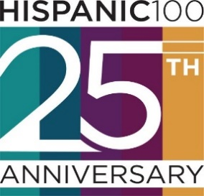
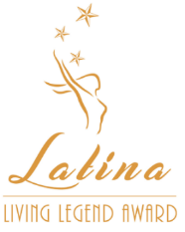

2021 NOMINATION FORM
LATINA LIVING LEGEND (LLL) AWARD

Send completed Nomination Form to connect@dfwhispanic100.org

THE HISPANIC 100, a group of professional Latinas in leadership roles, is seeking nominations for the Thirteenth Annual Latina Living Legend (LLL) Award. The award is presented to a Dallas/Fort Worth metro-area woman who has set a standard of excellence through her life’s work (25+ years)---by opening doors, leading through example, and serving as a catalyst for work that has directly benefited the community-at-large. The nominee’s impact should be measurable, meaningful, and substantive for the benefit of others within the community.

The deadline for nomination submission is 5:00 pm on Wednesday, June 30, 2021. Our honoree will be recognized at the Hispanic 100 Latina Living Legend / ELLA Awards Program on Thursday, September 30, 2021.

Nomination Form:

Nominator Information
Name
Address
Phone/Cell Phone
E-mail
Relationship to the Nominee

Nominee Information*
Name
Home Address
Phone/Cell Phone
Personal E-mail
Social Media Handle(s)
Employer
Work Address
Work E-mail
Position
Years in Position

Please submit a bio, high-resolution headshot of the nominee, and two (2) letters of recommendation with the completed Nomination Form to connect@dfwhispanic100.org.

• Maximum number of pages: Five pages including cover sheet, 12-point font
• Incomplete nominations and those received after the deadline will not be considered
• Nomination Form and attachments will not be returned

* Please note award recipient must provide photo assets as requested and be available for a promotional photo/video shoot
References
Please provide two (2) references that may be contacted to verify the scope and extent of the nominee’s contributions. References cannot include the nominee or relatives of the nominee.
Name:
Affiliation:
Address:
Phone:
E-mail:
Name:
Affiliation:
Address:
Phone:
E-mail:

Impact Statement (300-word maximum)
Describe the nominee’s life’s work (25+ years) in setting a standard of excellence by improving the quality of life for others while promoting multicultural understanding through access and equity.

Leadership Statement (300-word maximum)
Describe how the nominee’s efforts to start a new program or activity, developed ways to address critical needs within the community; solved problems, and/or promoted multicultural collaborations which served as a demonstrated catalyst for change.

Nomination Statement (300-word maximum)
What measurable/tangible results has the nominee accomplished?

Contribution Statement (300-word maximum)
Why do you believe the nominee merits the Latina Living Legend Award?

