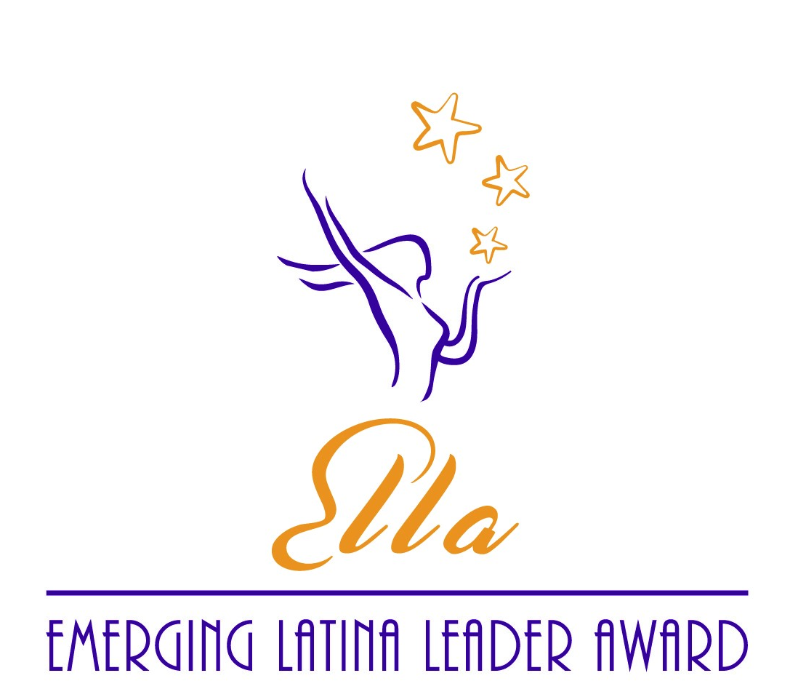
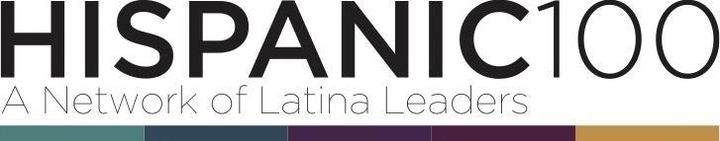

2022 NOMINATION FORM
EMERGING LATINA LEADER AWARD (ELLA)

Send completed Nomination Form to connect@dfwhispanic100.org

THE HISPANIC 100, a group of professional Latinas in leadership roles, is seeking nominations for the Annual Emerging Latina Leader Award (ELLA). The award is presented to a woman in the Dallas/Fort Worth metropolitan area that is making a significant difference in the lives of Latina women and girls through her personal engagement and leadership in her community, profession, and/or industry. To be considered, the nominee must be a Latina professional with a minimum of five (5) years of impactful service. The impact should be measurable, meaningful, and substantive for the benefit of others within the community, profession, and/or industry.

The deadline for nomination submission is Thursday, June 30, 2022 at 5 p.m.
Our honoree will be recognized at the Hispanic 100 Latina Living Legend / ELLA Awards Event on Thursday, September 15, 2022, 5:30-8:30 p.m. at Vouv Meeting and Event Space, 4445 Sigma Rd., Dallas, Texas 75244.

Nomination Form:

Nominator Information
Name
Address
Phone/Cell Phone
Email
Relationship to the Nominee

Nominee Information*
Name
Home Address
Phone/Cell Phone
Personal Email
Social Media Handle(s)
Employer
Work Address
Work Email
Position
Years in Position

Please submit a bio, a high-resolution headshot, and one (1) letter of recommendation for the nominee with the completed Nomination Form to connect@dfwhispanic100.org.

• Nomination materials are limited to five (5) pages including cover sheet, at 12-point font.
• Incomplete nominations and those received after the deadline will not be considered.
• Nomination Form and attachments will not be returned.

* Please note the award recipient must provide photo assets as requested and be available for a promotional photo/video shoot.
References
Please provide two (2) references that may be contacted to verify the scope and extent of the nominee’s contributions. References cannot include the nominee or relatives of the nominee.
Name:
Affiliation:
Address:
Phone:
E-mail:
Name:
Affiliation:
Address:
Phone:
E-mail:

Impact Statement (300-word maximum)
Share the impact that the nominee has made for Latina women and/or girls through personal, professional or community engagement. Highlight measurable results or examples through volunteerism, philanthropy, fundraising, mentorship, sponsorship and/or other efforts.

Leadership Statement (300-word maximum)
Share how the nominee has taken a leadership role through personal, professional or community engagement to make an impact for Latina women and/or girls at the local, state and/or national level.

Nomination Statement (300-word maximum)
Describe why you believe the nominee is an Emerging Latina Leader on the path to becoming a Latina Living Legend.

Additional Statement (300-word maximum)
Provide any additional considerations, awards, recognition, Board service or other information you would like to be considered with the application. You may also attach a copy of the nominee’s bio and/or resume.

